003 What is SAP HANA?

SAP HANA is a hybrid in memory database which combines row based, column based and object-based database technology. This is flexible data source agnostic appliance that enables customer to analyse large volumes of data that SAP and NON-SAP systems. It does this real time and best and the best thing is it avoids the need to materialize the transformations. These things allow customers to ask question in real time and get immediate answers, this allows us to get deep insight and answers on day-to-day basis. Since we are cutting down on different copies of data, this led to low DOC.

Can handle load of data in native way

Features of SAP HANA.

In memory storage

Multi Core Architecture

Columnar Storage - much faster on reading, faster aggregate functions

Partitioning

Compression - minimalizing data movement through compression

Massive parallel processing

HANA stores everything on RAM and processes all the data on RAM. So, it is faster than traditional HDD.

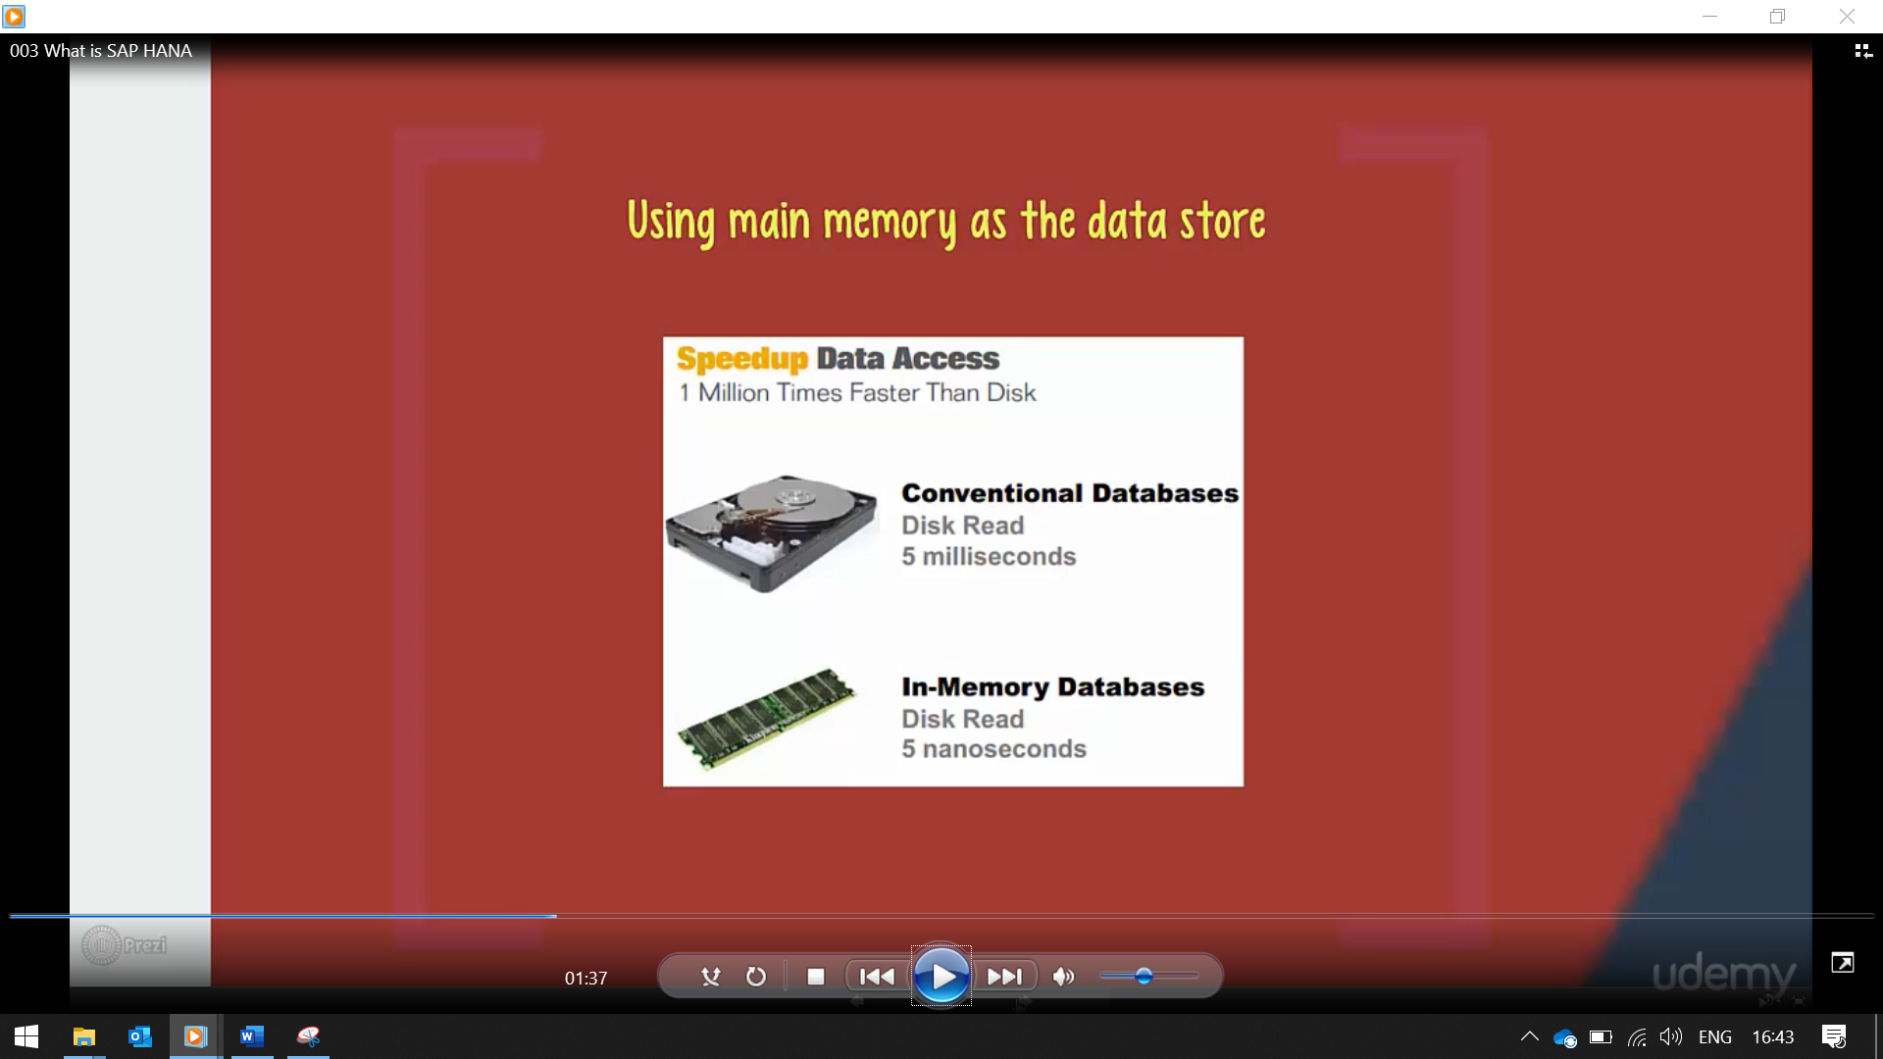

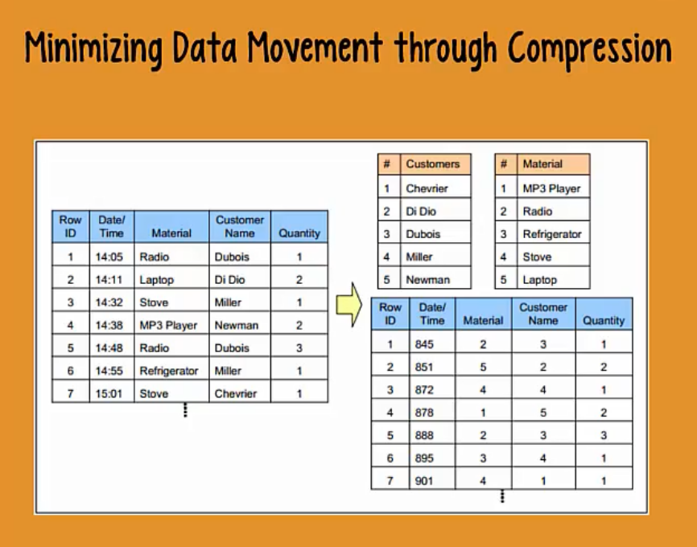

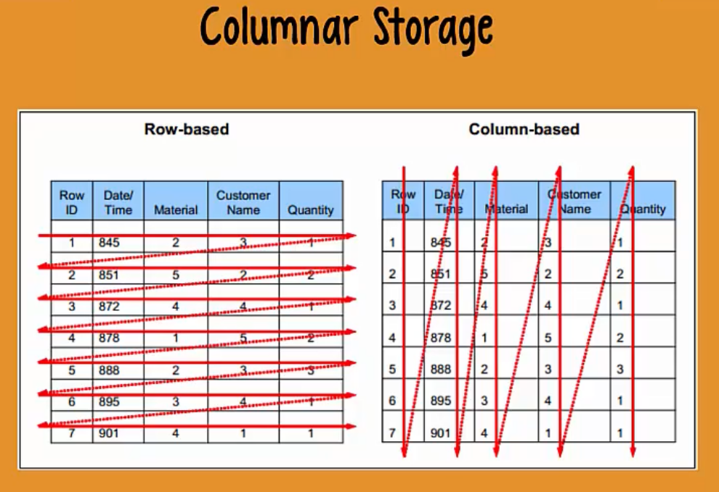

Pushing application layer to the database layer

-> MOVE calculations into database

-> Only transfer results

